|  |  |
| --- | --- |
| OPSC POE | Application Name: StepGoal  Application ID: SG003  Version: 3.0  Student Number: 17667327  Course: BCAD2  Subject: OPSC7311  Lecturer: Nirasha Ramckurran  Assignment: POE  Due Date: 05/11/2019 |

Contents

Introduction 2

Help File 3

Screenshots 7

Data Listing 21

Use Case Diagram 23

Conclusion 24

# Introduction

As part of our OPSC7311 module, we have been tasked with developing a step counting fitness application in the Java language for Android OS. The basic features of this application will include the ability for users to sign up/ in using a username and password, store and update personal details such as height, weight, and age. The user will also be able to specify if they wish to view height and weight values in metric or imperial units, on each page that it is required. Once signed in, they can change the default step count from 6000, and they can also set a target weight.

As part of our Task 3/ POE submission, a step counter has been included. Step count records can be saved to the database, which saves the current date along with the step count. These records are viewable on a bar chart on the “Fitness Log” page, which allows them to view fitness progress per day.

In addition to this, weight monitoring is another key feature which has been developed. The user may view weight trends using a bar chart on the “Weight Monitoring” page. They can add a new record, by selecting the “Add Record” button and entering their current weight and the date. All of these features allow the user to set units to either metric or imperial. Once saved, the user can view trends which are ordered by date on the bar graph.

The user can also compare current weight to target weight (weight goal), on the “Progress” page. This is accessible from the “Weight Monitoring” page.

Pictures can be taken from within the application, which will be saved to the phone gallery and viewable within the application (at the time of image capture). This allows users to capture health progress, including meals and exercises.

In the next section, a help file is provided which details all functionality of the application which has been implemented for Task 3/ POE. After this, screenshots will be provided, and a data listing of all data used within the application.

# Help File

The application provides numerous functions, which will be described in depth in the following section. The help file has been broken up into multiple sections, describing each part of the program.

**Login Page**  
When the user first starts the application, a login page is presented. This provides the following functionality:

* Username edit text
* Password edit text
* Register edit text
* Login button

The username input allows users to enter their unique account username, and below this they can enter their account password in the password textbox.

Below this, two buttons are displayed:

* Register: Brings the user to a registration page, which allows the user to register a new account on the system.
* Login: Brings the user to the main menu, where they can view their daily step count, along with distance travelled, etc.

**Register Page**When the user presses the “Register” button on the login page, a registration page is presented. This allows users to register a new account with the system, and provides the following functionality:

Account information can be entered, such as the following:

* Username edit text
* Password edit text
* Confirm Password edit text

After they enter their unique user account details, they will be brought to a page which allows them to enter personal details, including:

* First Name edit text
* Last Name edit text
* Weight (kg / lb) edit text
* Height (cm / in) edit text
* Age edit text

The user may enter their account information on this page, and select the “Save” button to save their personal information. Once saved, they will be brought back to the “Login” page and can enter their account username and password and will be brought to the home page.

**Home Page**Once the user has successfully logged in to their account, they will be brought to the home page, which provides a progress overview. This page contains the following functionality:

* Daily step count and diagram
* Step count goal
* Distance travelled (km / mi)
* Save step count button
* Metric / Imperial switch

The user may view the current step count for the day on the home screen, along with distance travelled, and daily step count goal. The user may save records to the database by pressing the “Save Step Count” button, and they can also change the units from metric to imperial or vice versa by selecting the switch.

The step count is obtained from the accelerometer in the phone, which is displayed on this screen. A progress bar indicates the number of steps counted over their currently set goal. Once the user reaches their daily goal, the diagram will change color to green, which indicates that they have reached the set goal.

The user may clear the current day progress by opening the nav drawer (top left of the screen), and press the “Erase Step Count” button. This will clear the current progress, which is stored in Shared Preferences, and will not affect records saved in the database.

The main menu can be accessed by logging in, or from the nav drawer “Step Counter” button.

**Goals**This page allows the user to set fitness goals, and includes the following functionality:

* Daily step count (spinner)
* Target weight (kg / lb)
* Metric / Imperial switch

The user can set the step count goal from this page, which will be displayed on the home screen. It will also update the diagram to reflect changes to progress, and changes will be made on other pages.

**Fitness Log**This page is accessed from the nav drawer, and allows users to easily track their step count on a bar graph. This page contains the following functionality:

* Step History bar chart
* Step count goal

The user can view their step history on this page, along with their set goal. Each bar chart item indicates a step count for their respective days. The user can scroll right to view more historical data.

**Pictures**This page provides functionality which allows users to capture images from within the application. They can press the “Take Picture” button to take a new picture, and it will be displayed on the activity page at the time of the image capture.

The image will be saved to the phone gallery, and can be accessed at any time by the user.

**Calculate BMI**The user can calculate their BMI by navigating to this page from within the nav drawer. This page provides the following functionality:

* Weight edit text
* Height edit text
* Metric / Imperial switch

The user can enter their current weight into the weight edit text, and height into the height edit text. When they click the “Calculate” button, it will display the result at the top of the screen. They can enter values in either imperial or metric units by selecting the “Metric / Imperial” switch.

**Weight Monitoring**Another key feature of this application is weight monitoring, which provides an easy way for its users to monitor their weight using a bar chart. This page provides the following functionality:

* Weight bar chart
* Target weight label
* Metric / Imperial switch
* Add record button

The user may view all weight trends on this page, and can scroll right to view older records. They can also select the “Metric / Imperial” switch to convert units.

When they select the “Add Record” button, a page is presented which allows users to enter new weight records. They can enter their current weight and pick a date from a calendar popup.

If the user were to select the “Progress” button, they will be brought to a page where they can view weight loss progress on a pie chart.

**Personal Information**This page allows users to view and update personal information, which was initially set during the registration process. This page provides the following functionality:

* First name edit text
* Last name edit text
* Weight edit text (kg / lb)
* Height edit text (cm / in)
* Age edit text
* Metric / Imperial switch
* Save button

The user can update their information by inputting data into the above controls. When they press the “Save” button, these values will be updated for the logged in user account. All height and weight values are stored in metric units, but can be viewed in either metric or imperial units.

**Nav Bar Functions**The user may access two additional features on the navigation bar, which include:

* Log out: The user can log out of their account by pressing this button.
* Erase Step Count: The user can erase the current step count for the day by pressing this button.

In addition to this functionality, the first name of the currently logged in user will be displayed on the nav bar header.

# Screenshots

**Login**When the user first opens the application, a login page is displayed. The user can either enter their username and password, and select the “Login” button, or select the “Register” button to register a new account.

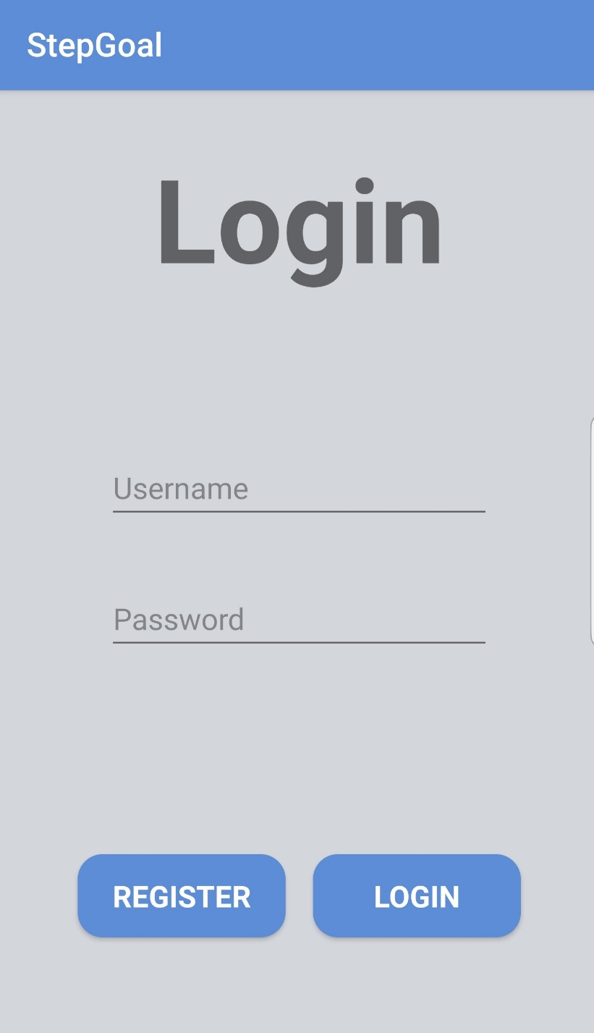

**Register**

If the user selects the “Register” button, they are brought to the following registration page. The user can enter a new username and password, and will be able to register their new account. After they select “Next” they will be brought to a page where they can input their personal details.

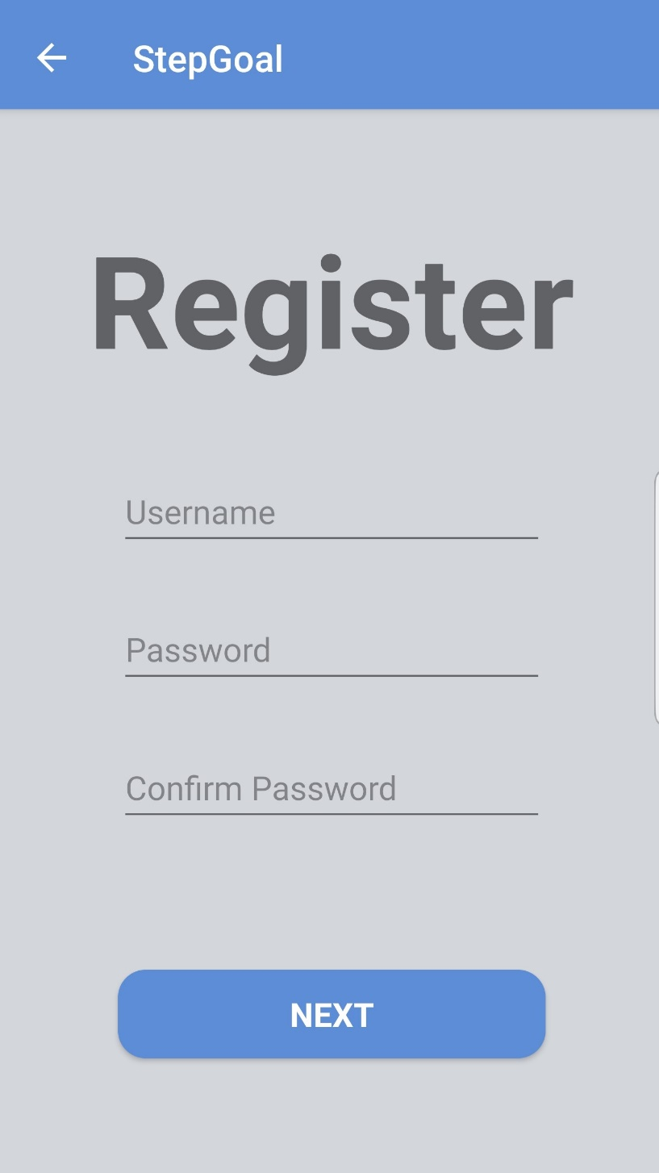

**Personal Details Page**Once the user has clicked the “Register” button, they will be brought to a page where they can enter their personal details, such as height, age, etc.

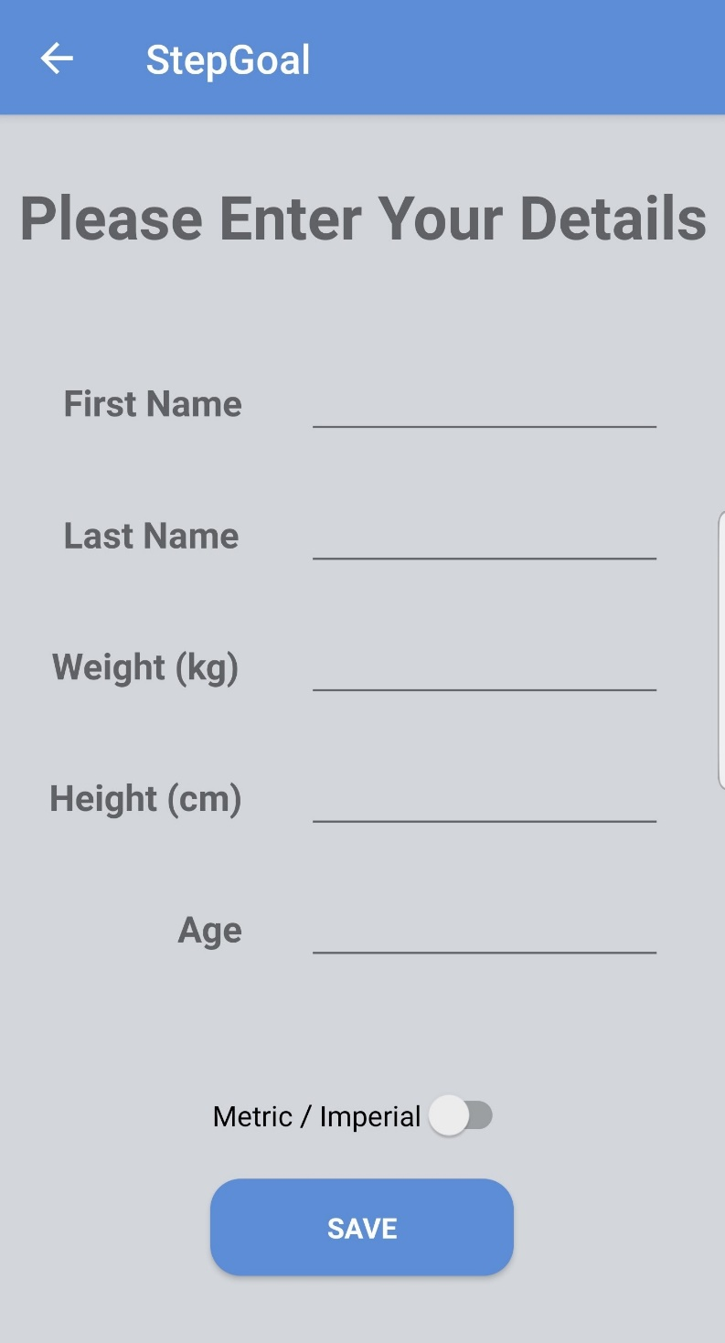

**Home**Once the user has logged in, they are brought to the home screen, which includes the following functionality:

* The daily step count of the user: From the accelerometer.
* Step count goal: User selected step count goal for each day. The progress bar shows current step count over goal step count (progress during the day).
* Distance travelled: The step counter will calculate distance travelled using step length (calculated from height).
* Imperial/ Metric conversion: The application can be set to either show values in imperial or metric units.
* Menu (displayed on the next page): Allows for easy navigation of functions.

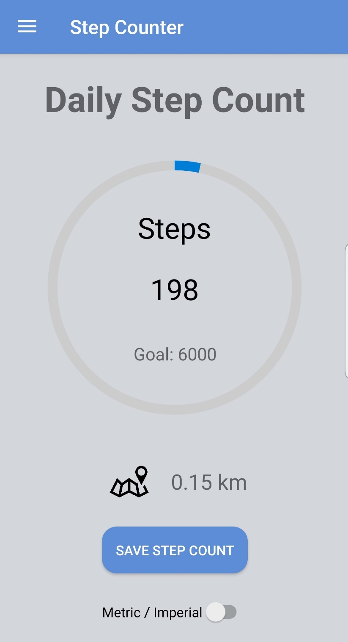

**Menu**

When the user selects the menu button (top left of home screen), a navigation drawer is shown. This provides access to the following functionality:

* Step Counter: Home screen.
* Goals: Allows users to specify a daily step count goal and weight targets.
* Fitness Log: Displays step count on a bar graph.
* Pictures: Allows the user to take pictures and view them from within the application.
* Calculate BMI: The user can calculate their BMI on this page.
* Weight Monitoring: Allows the user to enter their current weight, and shows trends on a bar graph.
* Personal Information: The user can set their personal information on this page.
* Log Out: Allows the user to log out of the application.
* Erase Step Count: Deletes the step count for the current day.

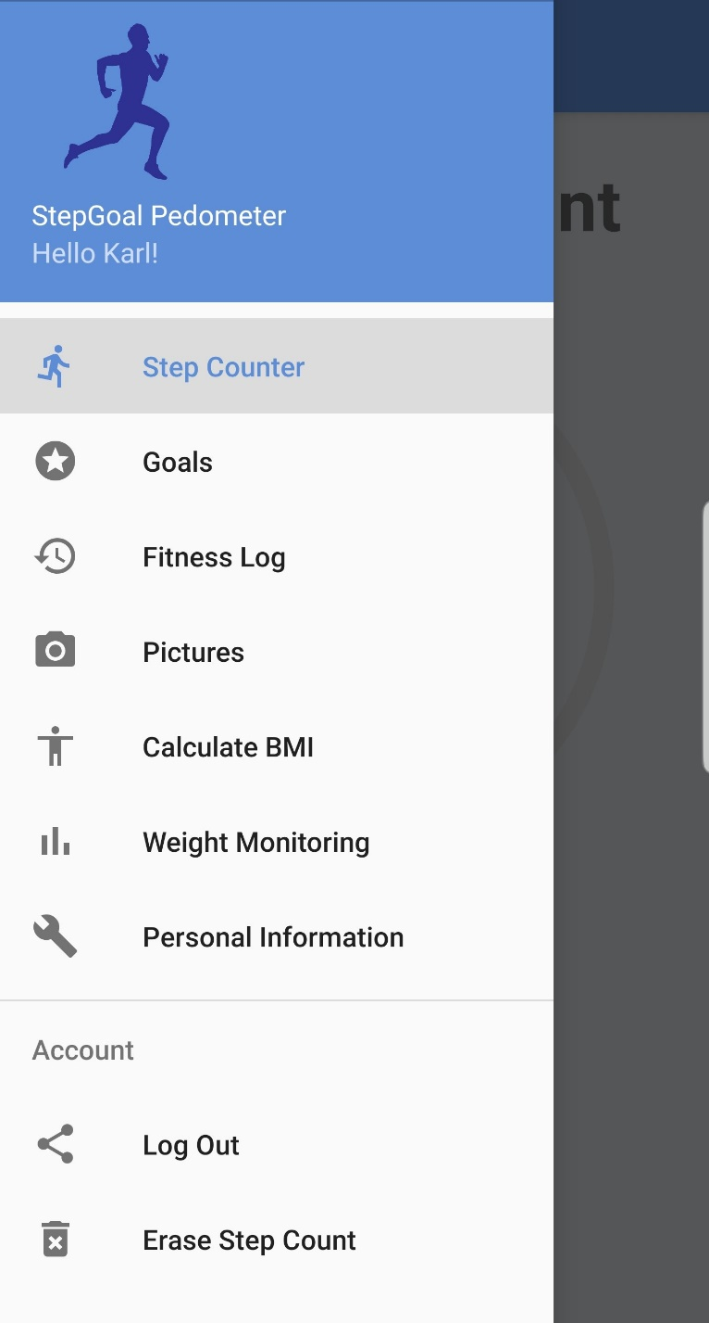

**Goals**

The user may set a daily step count goal, and weight target on this page. They may enter this information in either Imperial or Metric units using the toggle switch.

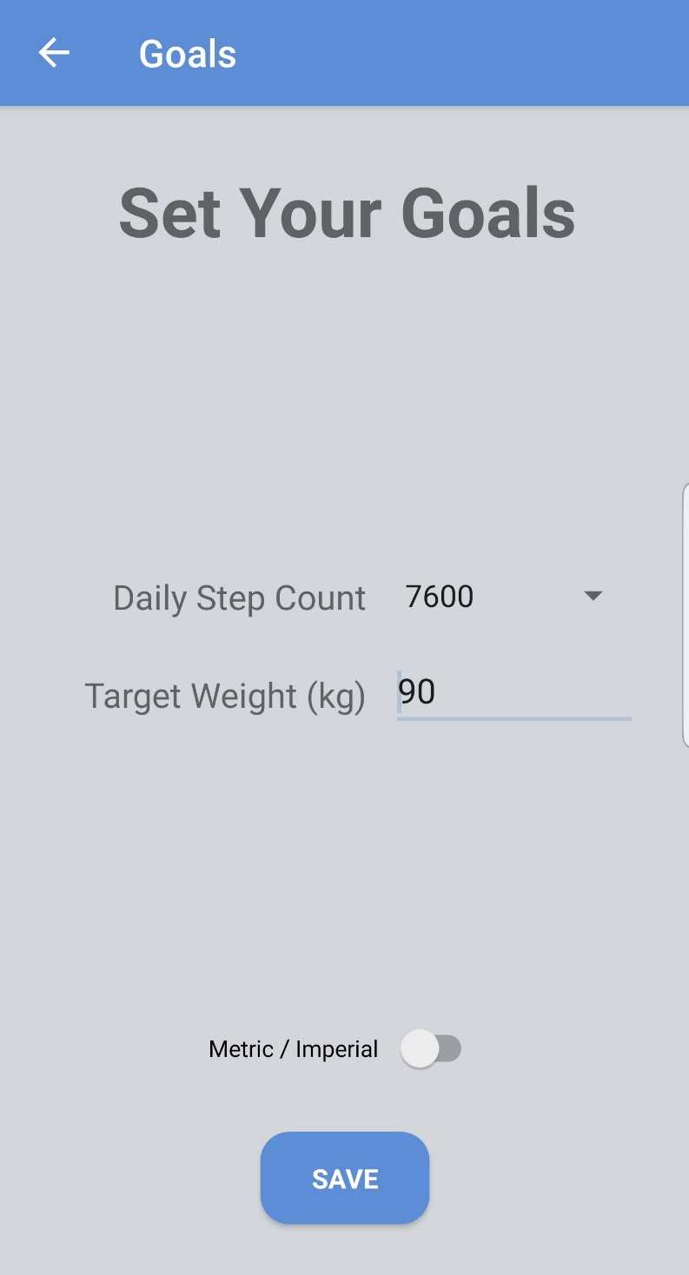

**Fitness Log**

The user may view their step count over the past four days, and scroll right to view more records within the “Fitness Log” page. It also displays their daily step count goal.

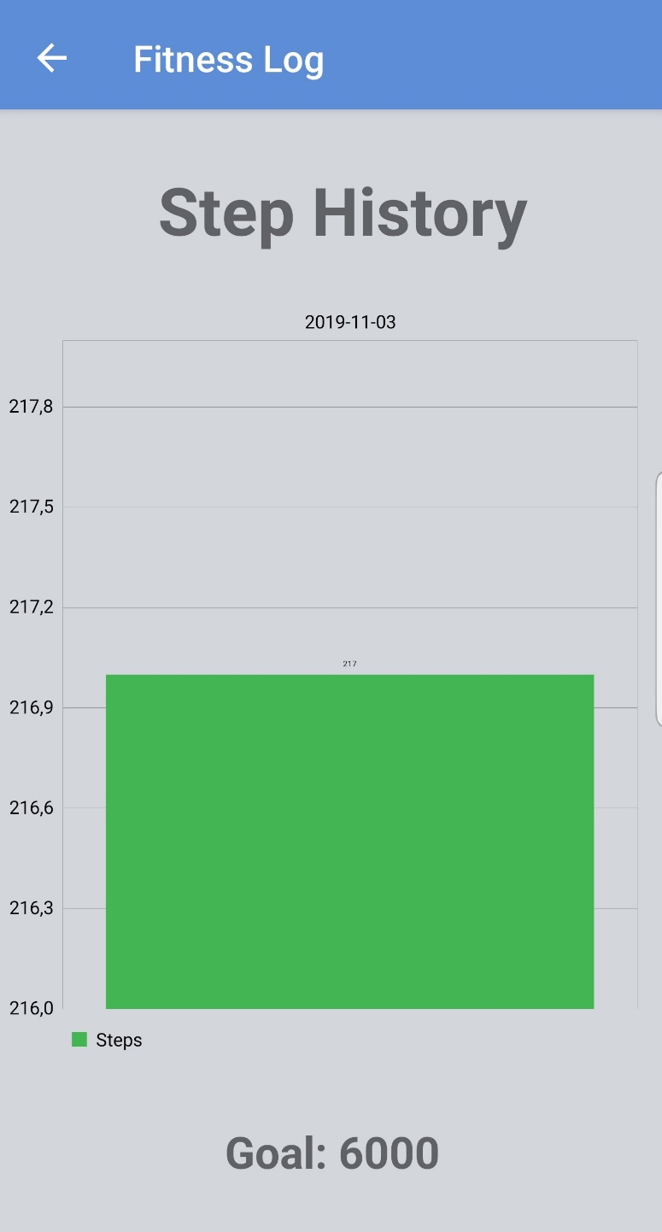

**Pictures**

This feature allows users to take pictures, and view them within the application. When the user selects “Capture Image”, it will bring them to a camera application, which displays the image above the button. The user may view the image within the application at the time that they capture the image, and within the phone gallery later on.

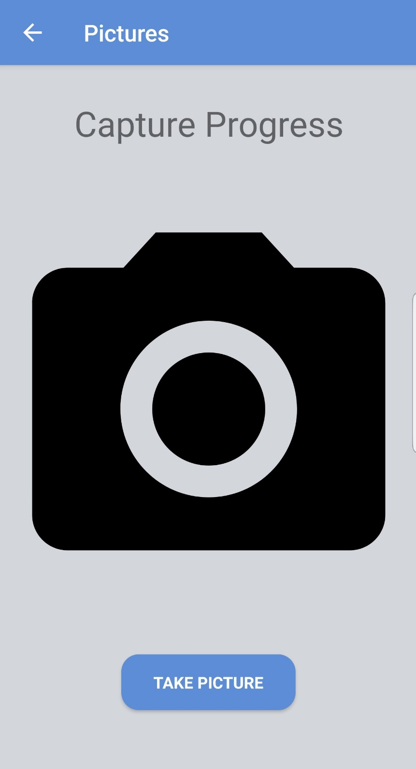

**Calculate BMI**

When the user selects this menu item, the user is brought to a page which allows them to enter their weight and height, and it will calculate their BMI once they press the “Calculate” button. Units have been set to imperial on this page, and all other pages will work similarly.

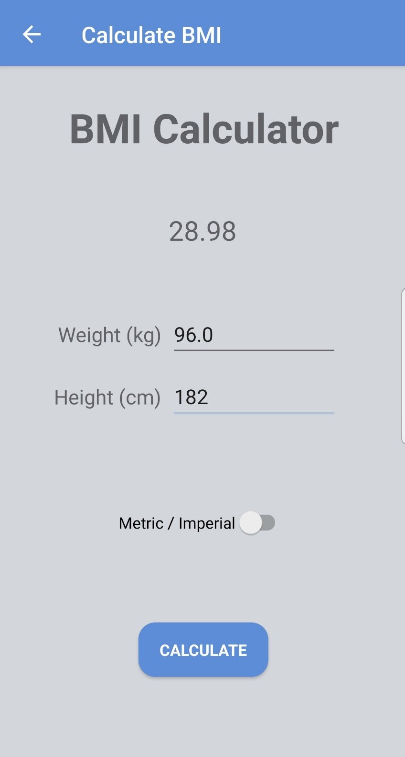

**Weight Monitoring**

The weight monitoring page will allow the user to view weight trends. If they select the “Progress” button, a page will be displayed which indicates weight loss statistics. If they select the “Add Record” button, they can add a new weight record to the database.

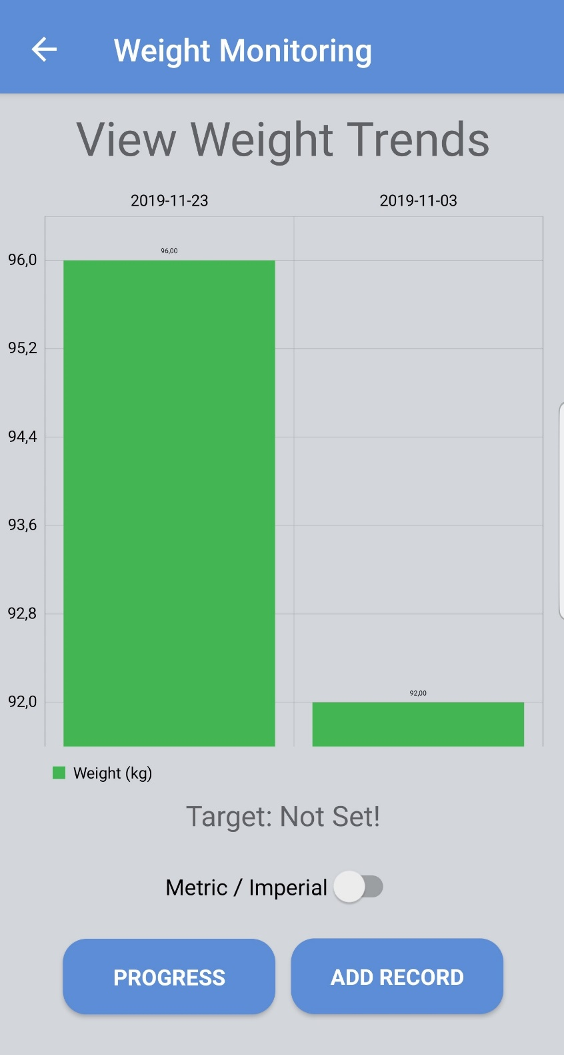

**Add Weight Record**

The user may add a new weight record on this page.

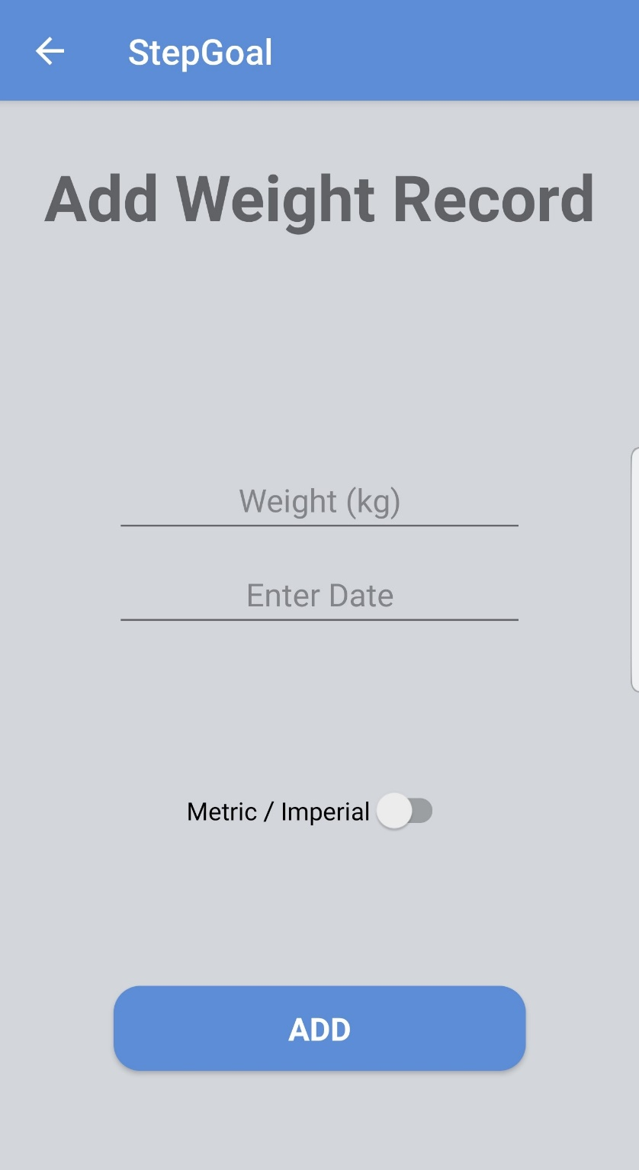

**Weight Progress**

The user may view weight progress on the “Progress” page. This page provides weight goal and current weight information. It calculates the weight loss left until the user reaches their target weight.

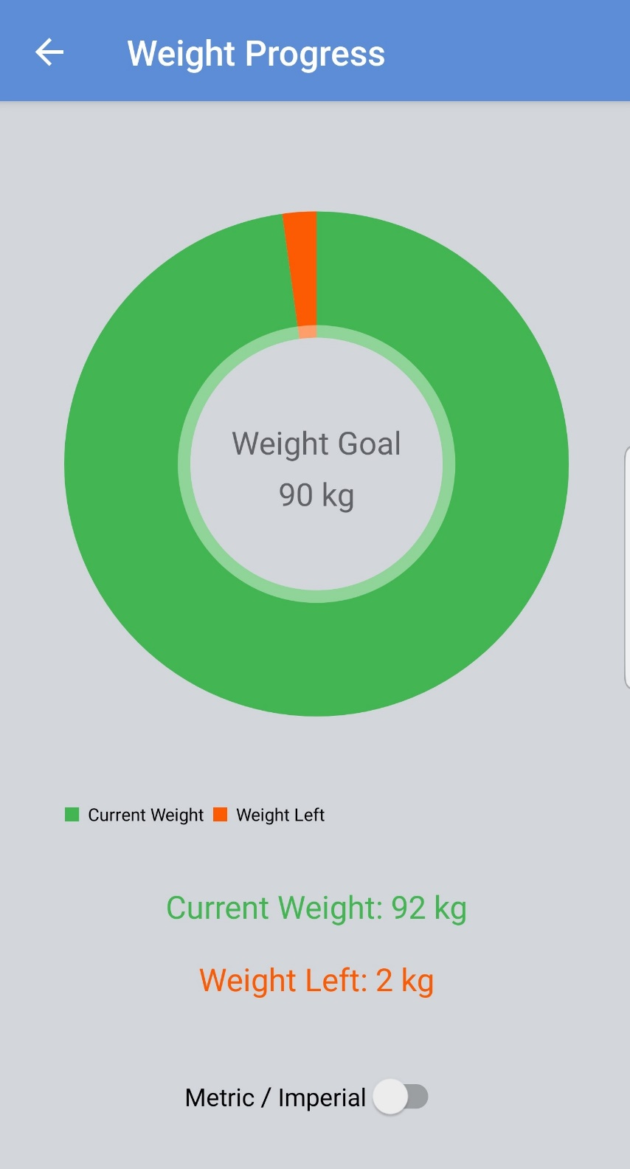

**Personal Information**

The user may edit their personal information on this page, including:

* First Name
* Last Name
* Weight
* Height
* Age

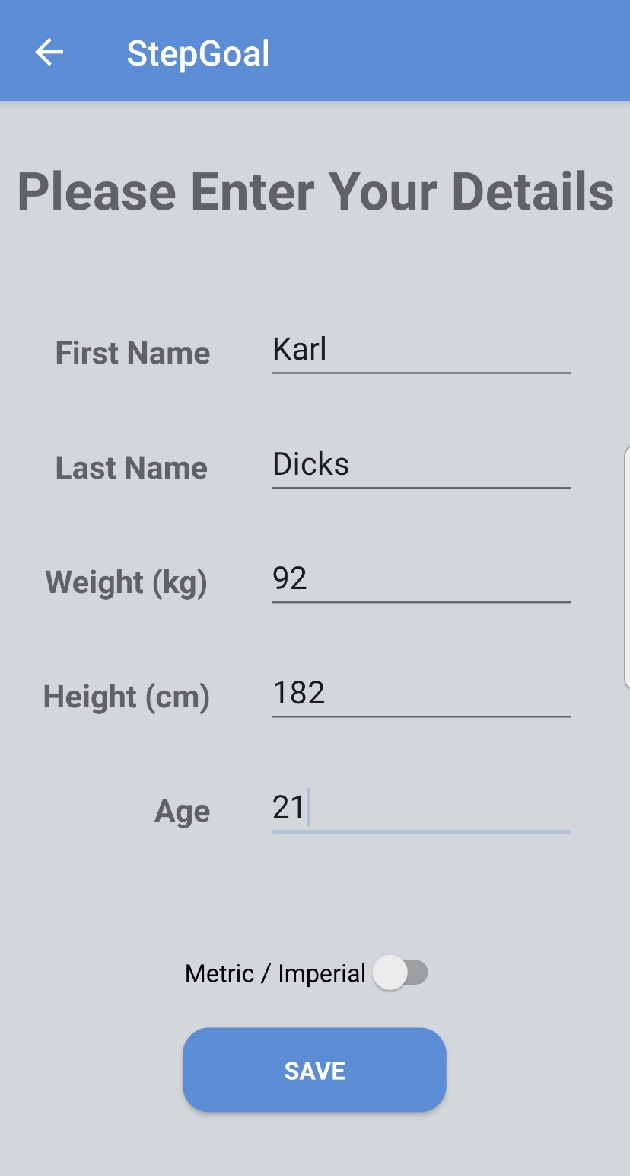

**Personal Information (imperial units)**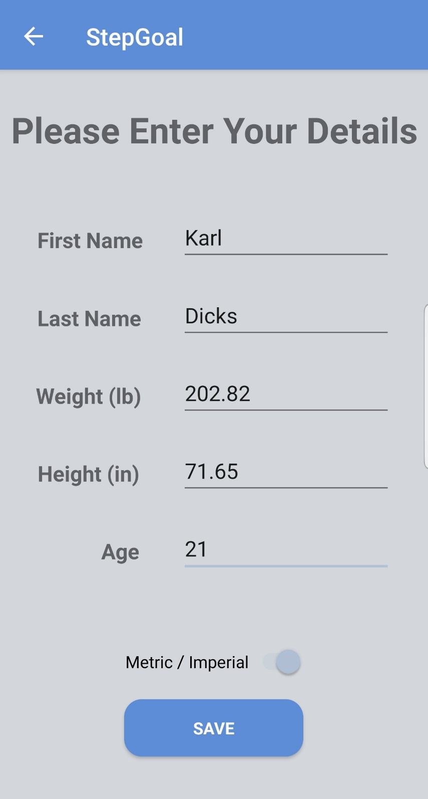

If the user selects the Imperial/ Metric toggle button, the units will be changed from centimetres and kilograms, to inches and pounds, as shown on this page.

# Data Listing

|  |  |  |  |  |
| --- | --- | --- | --- | --- |
| **Data Name** | **Type (Java)** | **Type (SQL)** | **Nullable** | **Length** |
| **Username** | String | Text | False | 255 |
| **Password** | String | Text | False | 255 |
| **First Name** | String | Text | False | 25 |
| **Last Name** | String | Text | False | 25 |
| **Age** | Int | Text | False | 3 |
| **Height** | Int | Text | False | 3 |
| **Weight** | Int | Text | False | 3 |
| **Step Goal** | Int | Text | True | 25 |
| **Target Weight** | Double | Text | True | (5, 2) |

Some data will be calculated within the application, including:

|  |  |  |  |  |
| --- | --- | --- | --- | --- |
| **Data Name** | **Type (Java)** | **Type (SQL)** | **Nullable** | **Length** |
| **BMI** | Double | Text | True | (5,2) |
| **Total Step Count** | Int | Text | True | 255 |
| **Daily Step Count** | Int | Text | True | 255 |
| **Completed Step Goal Percentage** | Double | Text | True | (250, 2) |
| **Completed Weight Goal Percentage** | Double | Text | True | (250, 2) |

Some considerations have been taken when implementing this application:

* All data has been stored in Metric units, and only displayed in Imperial units if the user requests this conversion.
* All information stored on the device can only be accessed by the logged in user. A username/ password authentication mechanism will provide this security.
* Daily step count is refreshed when a save button is selected, in order to prepare the application for the next day. The count is saved to a database, and reset on the device.
* Step Goal and Target Weight are nullable, as users do not have to set these values. They can use the pedometer without goals.
* The daily step count goal is set to 6000 by default, much like most pedometer applications available on the Play store.
* An SQL Lite database is available on all Android smartphones, which provides limited relational database functionality. This database has been used to store all data in the system, including login information for the user.
* All data has been stored in Text format, as SQL Lite provides limited data types and functionality.

# Use Case Diagram

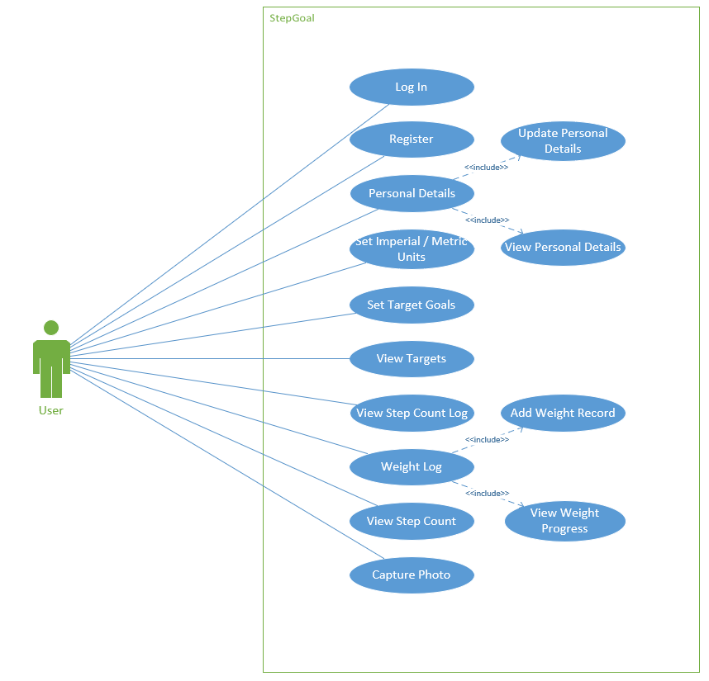

# Conclusion

Within this document, extensive information was provided in order to detail how and why the application was developed in the way that it was. It described the functions of each page within the “Help File” section, and provided design information within the “Screenshots” section. Additional information such as a data listing was provided, which detailed how and where data was stored by the application. Lastly, a use case diagram was included, which showed all functionality of the program.

During the course of this project, we have learnt how to develop basic Android applications in Java programming language and XML. We also learnt how to use an SQL Lite database, which provides a versatile relational database on most Android devices by default, and has been used by StepGoal pedometer.

With this knowledge obtained, we have been able to improve our Task 2 assignment for our POE submission. This included numerous improvements and feature updates.